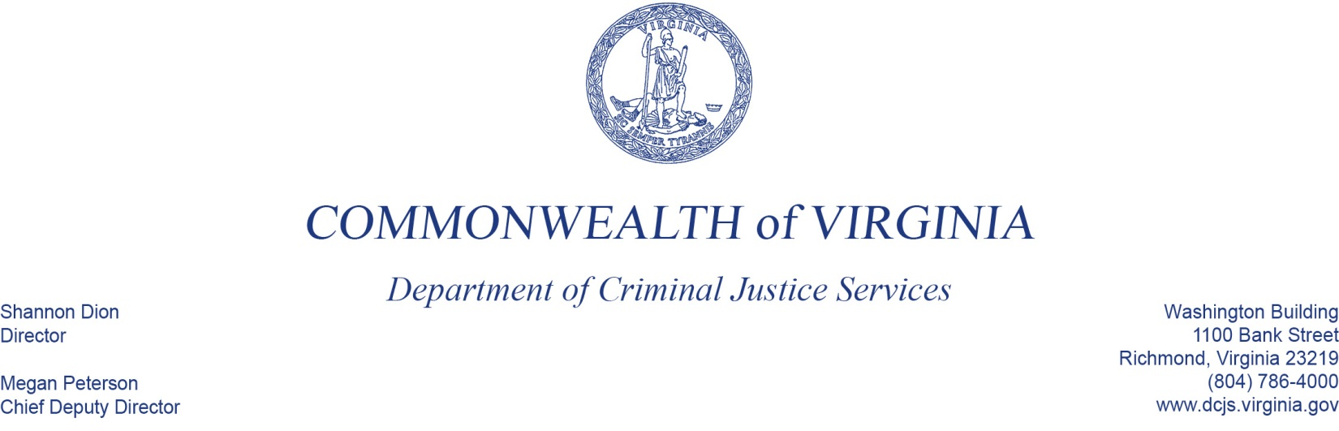
March 2, 2020

Ms. Sheree Hedrick
Executive Director
Hanover Safe Place
629-A N. Washington Hwy
Ashland, VA 23005-1326

Dear Sheree Hedrick,

This letter is to confirm that I will be conducting a site visit to monitor activities funded through your DCJS grants # 20-A3582VP18,20-K2212SP19, 20-X9411VA19. I plan to arrive at approximately 10:00AM on Tuesday, May 12, 2020 to conduct the review.

I have included a copy of the monitoring instrument as well as a list of the documents that will be reviewed during the visit. I encourage you to place the documents in a binder (organized by fiscal year FY 17-20) and have them available for easier access during the meeting. This will not only increase efficiency but save time during the visit so that we may focus on technical assistance needs. We will also need ample meeting space to review multiple documents and discuss procedures.

As a part of the review, I would like to meet with the following persons:
- all DCJS grant funded staff,
- the grant program finance officer,
- the sponsoring agency head, and,
- if applicable, other staff responsible for grant related matters.

If you have any questions or need further information, please call or e-mail me at 804-786-1165 or tierra.smith@dcjs.virginia.gov.

I look forward to visiting with you and learning more about your grant program(s) and the services you provide.

Sincerely,
Tierra Smith, MSW
Victims Services Program Specialist,
Office of Victims Services,
Division of Programs and Services

Enclosure
ec: Albert Stokes, Manager, Office of Grants Management, Division of Finance and Administration, DCJS
Kristina Vadas, Manager, Office of Victims Services, Division of Programs and Services, DCJS
Amia Barrows, Victims Services Grant Monitor Supervisor, Office of Victims Services, Division of Programs and Services, DCJS
DCJS Central Files

